Appreciating Leadership Excellence – Passion and Commitment
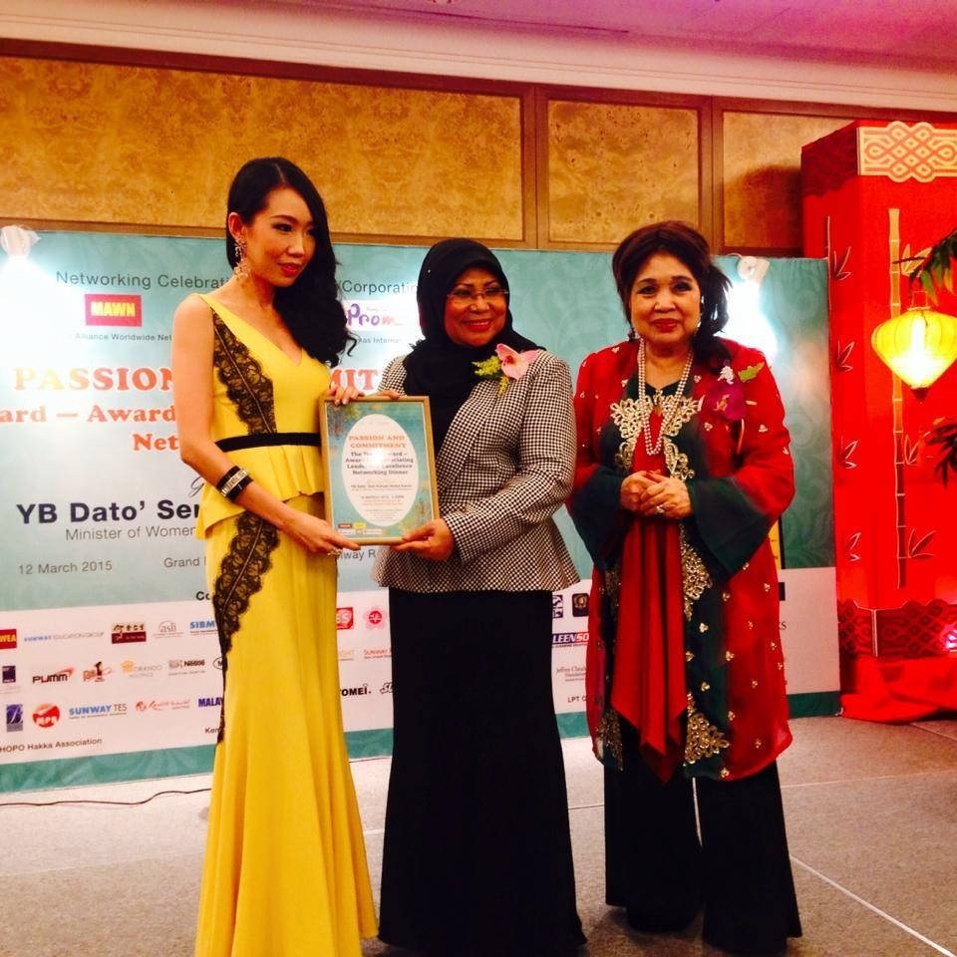

Award given by the Minister of Women, Family and Community Development YB Dato’ Seri Rohani Abdul Karim.

