Source: Malaysia Tatler Society, January 2008

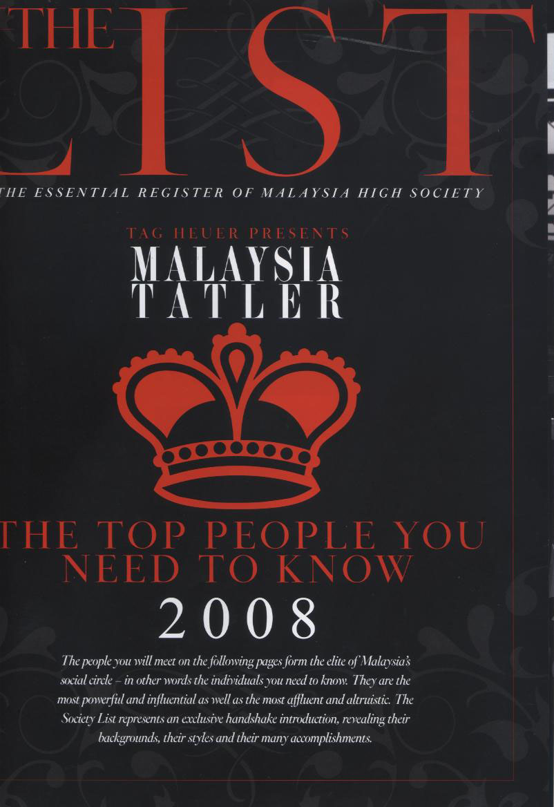

Source : Malaysia Tatler Society, January 2010
Mi-Ki was featured in ‘The List of Who’s Who of Malaysia’ in the Tatler Society List, comprising of well-known dignitaries in Malaysia
